LOAN ELIGIBILITY ASSESSMENT

Abstract
This project develops a classification model to predict whether a loan application is likely to be Approved or Rejected. The workflow is created in IBM SPSS Modeler 18.6 using a loan approval dataset. The data is imported, field roles are checked, the records are divided into training and testing partitions, and a C5.0 decision-tree model is trained. The trained model is then used to generate predictions, which are reviewed using output and model evaluation results.

1. Introduction
Loan eligibility assessment is an important task for financial institutions. A lender considers multiple factors, such as annual income, requested loan amount, credit score, loan term, employment status, dependants, and asset values, before deciding whether to approve an application. Data analytics can help identify patterns in historical applications and support consistent decision-making.
In this project, IBM SPSS Modeler 18.6 is used to build a supervised classification workflow. The target field is loan_status, which contains the two classes Approved and Rejected.

2. Objectives
- Import the loan approval dataset into IBM SPSS Modeler.
- Check the input fields and assign the correct target role to loan_status.
- Split the records into training and testing partitions.
- Train a C5.0 classification model.
- Apply the trained model to produce predicted loan-status values.
- Review predictions and evaluate the model's reported performance.

3. Software and Dataset
Software: IBM SPSS Modeler 18.6.
Dataset file: loan_approval_dataset.csv.
Target field: loan_status (Approved / Rejected).
Input fields used in the dataset:
Field | Meaning
no_of_dependents | Number of dependants
education | Education category
self_employed | Whether the applicant is self-employed
income_annum | Applicant's annual income
loan_amount | Requested loan amount
loan_term | Loan term
cibil_score | Credit score
residential_assets_value | Value of residential assets
commercial_assets_value | Value of commercial assets
luxury_assets_value | Value of luxury assets
bank_asset_value | Value of bank assets
loan_status | Outcome to be predicted

4. Methodology / Stream Overview
The stream follows this general sequence: File source → Type node → Partition node → C5.0 modeling node → generated model nugget → prediction/output and evaluation. The source node reads the CSV file. The Type node defines measurement and field roles. The Partition node separates training and testing data. The C5.0 node learns classification rules from the training records. The generated model nugget applies those rules to records and creates a predicted field.
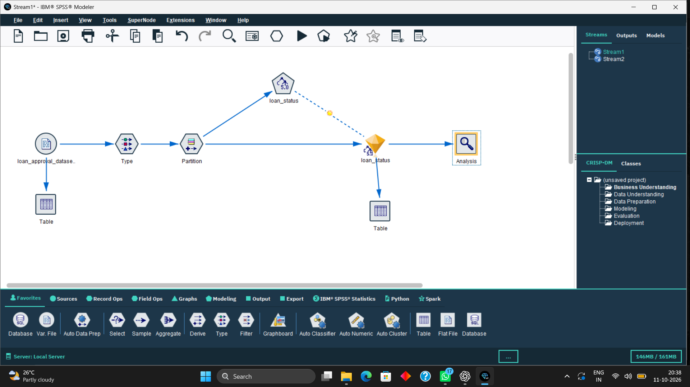

5. Step 1 — Import the Dataset
Purpose: Load the loan application records into SPSS Modeler so the data can be prepared and modeled.

Procedure
- Open IBM SPSS Modeler 18.6 and create a new stream, or open the existing saved stream.
- Add or select the source node used to read a file. For a CSV dataset, this is typically a Var. File or equivalent file-source node, depending on the stream setup.
- Browse to loan_approval_dataset.csv and select it as the input file.
- Check that the field names are read from the first row and that the preview shows the expected columns and records.
- Run the source node or preview the data to confirm that the file is readable.

Expected Output / Verification
The data preview should show the loan application fields, including income_annum, loan_amount, cibil_score, and loan_status. If the file cannot be found after moving the stream, update the source path to the current CSV location.
[Figure 2. Dataset source node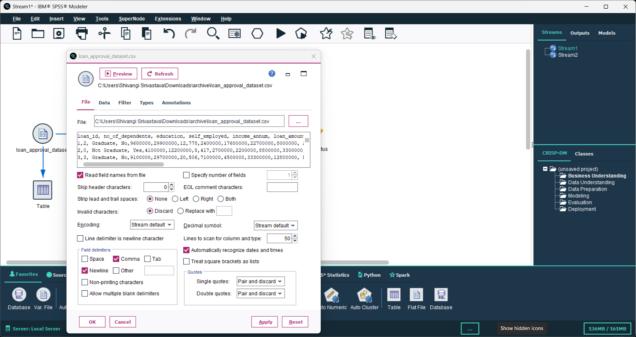 and

6. Step 2 — Configure the Type Node
Purpose: Tell Modeler how to interpret each field and identify the variable the model must predict.

Procedure
- Open the Type node connected to the source node.
- Review the listed field names and confirm that numeric fields are recognized as numeric and categorical fields as categorical where appropriate.
- Locate the loan_status field.
- Set the role of loan_status to Target. The remaining predictor fields should normally have the role Input.
- Confirm the values/classes for loan_status are Approved and Rejected, and apply the settings.

Expected Output / Verification
The target must be loan_status. If it is incorrectly set as Input or None, the model will not be trained to predict the intended outcome.
Note: Field measurement/type settings may vary slightly depending on how the CSV was imported. Preserve the actual field names used in the dataset.
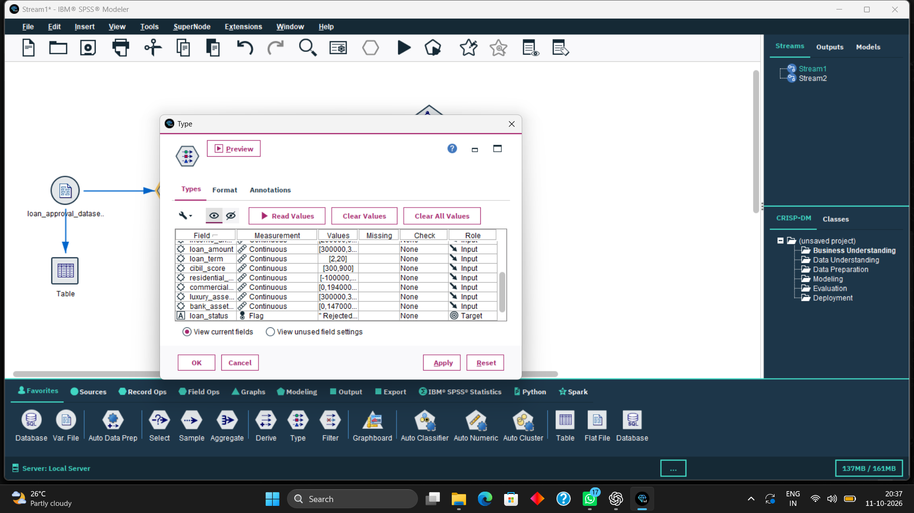

7. Step 3 — Partition the Dataset
Purpose: Hold back a portion of records for testing so performance can be checked on data not used to train the model.

Procedure
- Open the Partition node placed after the Type node.
- Set the partition proportions to 70% for training and 30% for testing, if these are the settings used in your stream.
- Check that the partition field or generated partitioning mechanism is enabled.
- Apply the settings and ensure the Partition node is connected before the C5.0 node.
- Run or refresh the node if needed so the partition assignment is available to the modeling node.

Expected Output / Verification
The workflow should use the training partition to build the model and the testing partition to evaluate it. The split ratio should match the settings shown in your screenshot.
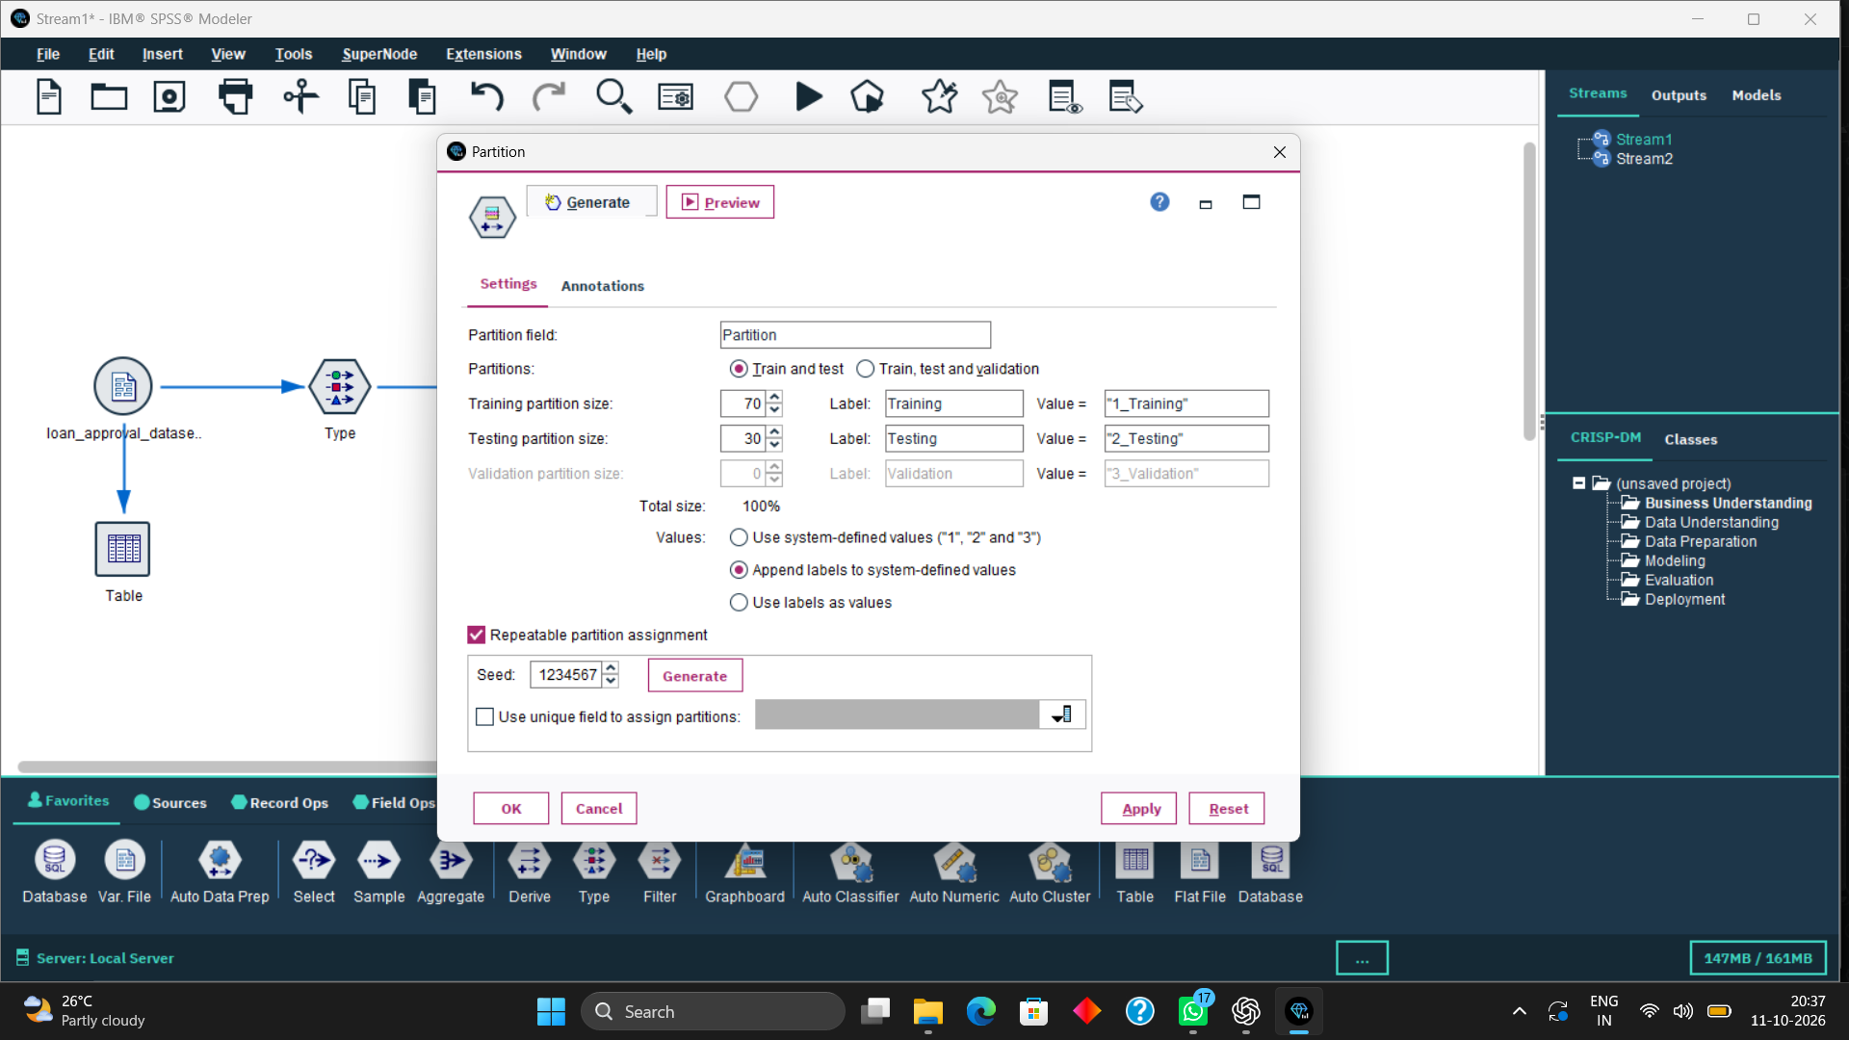

8. Step 4 — Configure and Train the C5.0 Model
Purpose: Train a decision-tree-based classification model that learns relationships between applicant information and loan_status.

Procedure
- Open the C5.0 modeling node.
- Confirm that loan_status is the target field, based on the Type node settings.
- Review the available model options and retain the settings used for this project unless your instructor has specified otherwise.
- Run the C5.0 node. Modeler will use the training records to learn rules that distinguish Approved from Rejected applications.
- After training finishes, confirm that the generated model nugget appears on the stream canvas.

Expected Output / Verification
A model nugget should be created. It contains the learned classification rules and can be connected to downstream records to generate predicted loan status.
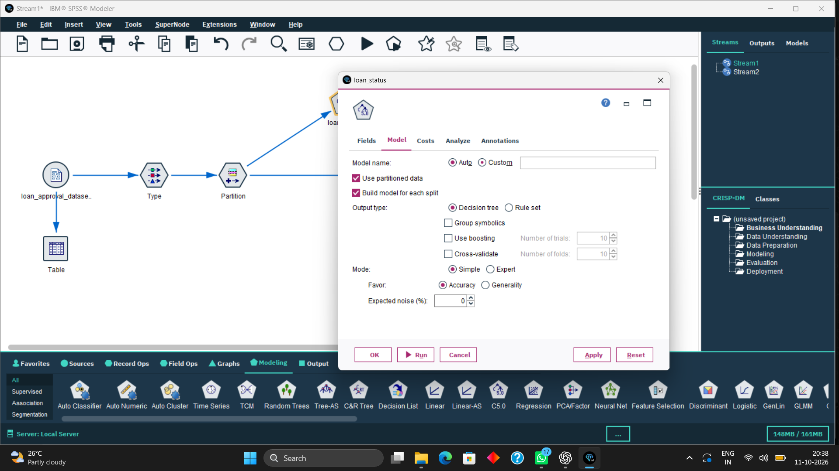

9. Step 5 — Apply the Model Nugget
Purpose: Use the trained model to classify records and generate a predicted loan-status field.

Procedure
- Locate the model nugget generated by the C5.0 node.
- Ensure it is connected to the appropriate data stream for scoring or prediction.
- Run the downstream stream or execute the nugget against the selected records.
- Open the output table and locate the original loan_status field and the generated prediction field. In this project, the predicted field may appear as $C-loan_status.
- Compare actual and predicted values for a sample of records.

Expected Output / Verification
The output should contain both the original loan_status and the predicted field. The prediction field represents the class selected by the model; it does not replace the original target field.
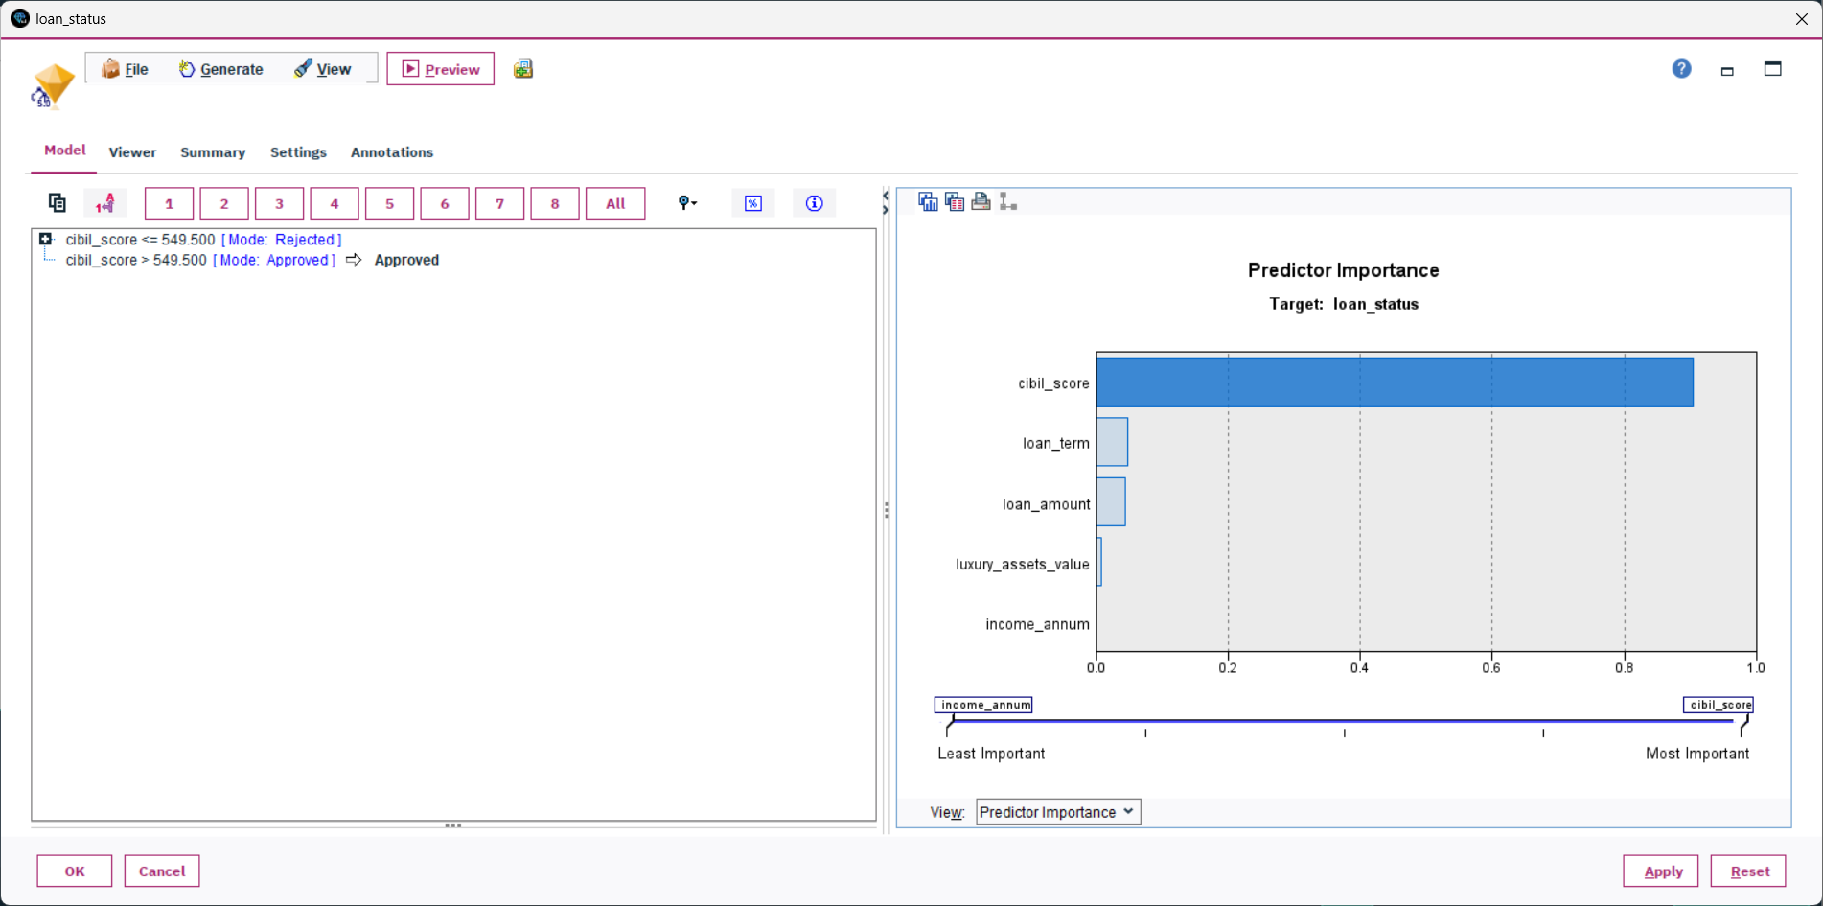

10. Step 6 — Review the Table Output
Purpose: Inspect individual predictions and confirm that the model is producing the expected output.

Procedure
- Open the Table output node or table result connected after the model nugget.
- Check that rows are displayed and that the original loan_status field is present.
- Find the predicted field, commonly displayed as $C-loan_status.
- Compare actual and predicted values for a few records. Matching values indicate correct classification for those rows; mismatches indicate classification errors.
- Take a screenshot with the column headings and several rows visible, making sure the text is readable.

Expected Output / Verification
The table should show actual and predicted loan-status values. A few matching rows demonstrate how the model scores applications, but the full model performance should be assessed using an evaluation result rather than only a small sample.
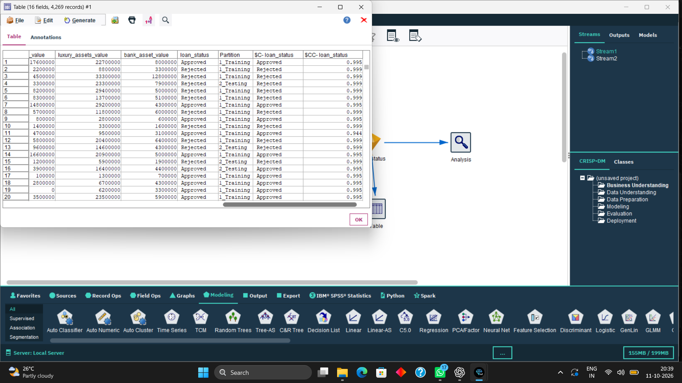

11. Step 7 — Evaluate Model Performance
Purpose: Assess how well the trained model classifies the testing records.

Procedure
- Open the Analysis or evaluation result that was used in the project.
- Identify which partition the reported result refers to (training or testing).
- Record the reported accuracy, number of testing records, number classified correctly, and number classified incorrectly, if these are displayed.
- Use the screenshot of the actual results to enter the exact figures in the report.
- Do not interpret training accuracy alone as proof of generalization; testing performance is the more useful indicator of how the model may perform on unseen records.

Expected Output / Verification
The project results previously recorded from the output were: training accuracy 99.09%; testing accuracy 98.24%; testing records 1,310; correctly classified 1,287; incorrectly classified 23 (1.76% error). Please verify these values against the final results screen before submission.
Note: Accuracy is the proportion of records classified correctly. Results depend on the dataset, partition, and node settings; they are not a guarantee of real-world lending outcomes.
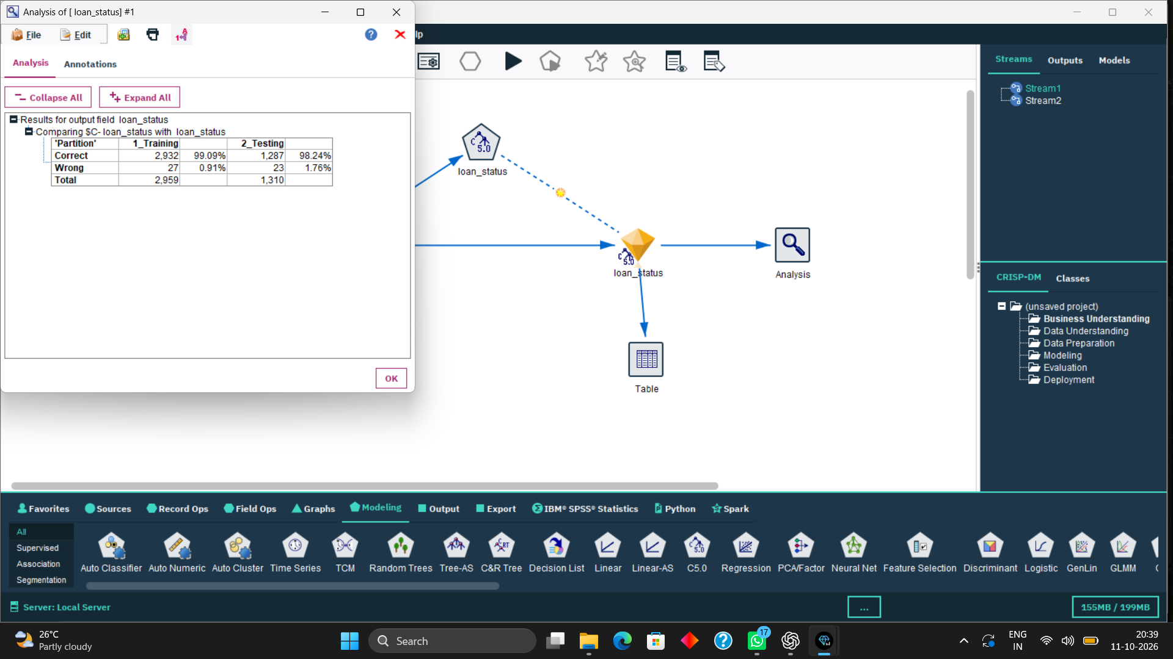

12. Results and Discussion
According to the results previously recorded from the project output, the model reported 99.09% training accuracy and 98.24% testing accuracy. For 1,310 testing records, 1,287 were classified correctly and 23 were classified incorrectly. The corresponding testing error rate was approximately 1.76%.
The difference between training and testing accuracy is small in the recorded output, which suggests that the model performed similarly on the two partitions. However, accuracy alone does not describe all types of errors. In a loan setting, false approvals and false rejections can have different costs, so a confusion matrix, class-wise precision/recall, and review of the data quality would provide a more complete evaluation.

13. Conclusion
This project demonstrates a complete classification workflow in IBM SPSS Modeler 18.6. The dataset is imported, field roles are checked, records are partitioned, and a C5.0 model is trained to predict loan approval status. The model nugget is then used to generate predictions, which are reviewed in a table and evaluated using the available analysis output. The recorded testing result is promising, but it should be validated against the final Modeler output and interpreted with awareness of dataset limitations.

14. Limitations and Future Scope
- The model learns patterns from the available historical dataset; data quality and representativeness affect results.
- High accuracy on one split does not guarantee the same performance on new applicants or in a different lending environment.
- Further evaluation can include a confusion matrix, precision, recall, F1-score, and class-wise error analysis.
- The model should support, not automatically replace, responsible human review and applicable lending policies.

References
IBM SPSS Modeler 18.6 — software used to construct and execute the classification stream.
Dataset: loan_approval_dataset.csv (Kaggle dataset supplied for this project; cite the exact dataset page/link required by your instructor).

